Packet Hub
159, Jalan Templer
46050 Petaling Jaya
Selangor Darul Ehsan
Malaysia.

Tel: +60-3-74508888
Fax: +60-3-74508899

Quick User Guide
For DX WIMAX Indoor Modem

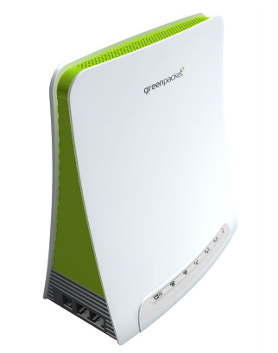

Prepared by:
Green Packet Berhad

Date:
November 24, 2010

Document Information

Title: | DX WiMAX Indoor Modem Quick User Guide | Prepared by: | Khor Hock Lin
Our Reference #: |  | Approved by:
Document Version: | Rev 1.0 | Document Date: | Nov. 24, 2010

Document Distribution/To

Company | Purpose** | Attention | Tel/Fax/Email

Updated Document
Rev. | Release Date | Updated By | Approved by | Description of Change

TABLE OF CONTENTS

1. GENERAL 4
2. GUI INTERFACE CONNECTION 5
3. CONFIGURATION DX INDOOR MODEM 7
3.1. Status of WiMAX 7
3.2. WiMAX Frequency Configuration 8
3.3. WiMAX Authentication Configuration 9
3.4. WIFI Configuration 10
3.5. Firmware Upgrade 12
3.6. Recovery 13
3.7. Logout and Reboot 14
3.7.1. Logout 14
3.7.2. Reboot 14

GENERAL

This quick user guide is intended as a reference source of configuring the DX indoor modem.

  - Hardware Requirements

The hardware requirements of DX are shown in the table below:-

No. | Descriptions | Specifications | Qty
A | Hardware Requirement
1 | DX WiMAX Indoor Modem | c/w Power Adapter and RJ45 Network cable | 1 set

ACCESS MODEM GUI

Follow the steps below to login to DX GUI through your pc or laptop. Prior to configuration, please ensure that the above mentioned requirements are met.

Web Browser to Login into DX GUI
- Use the network cable provided to connect DX WiMAX Indoor Modem to the LAN port of your laptop or PC.
- Power ON and allow the laptop or PC to detect the network connection.
- Double-click on Internet Explorer, go to http://10.1.1.254 and login with the following default credential:
- Username: admin
- Password: admin

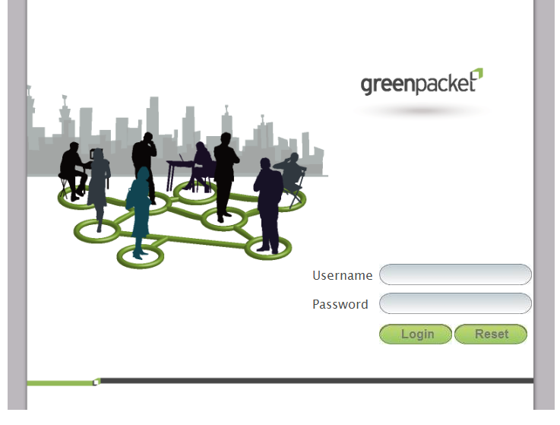

If Internet Explorer cannot display the webpage
Please follow the following instruction:-
- Run command prompt (press Window button + r button) and key in “cmd”

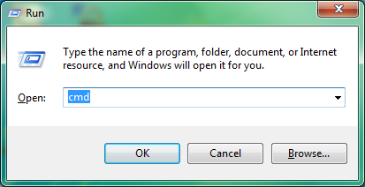

- Key in “ipconfig” to check the status of local LAN network information

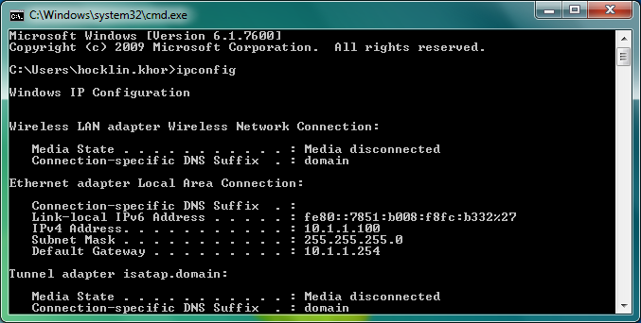
Default Gateway IP address

- Double-click on Internet Explorer, go to http://x.x.x.x and login with the following default credential:
- Username: admin
- Password: admin

DX INDOOR MODEM CONFIGURATION

Status

WiMAX Status
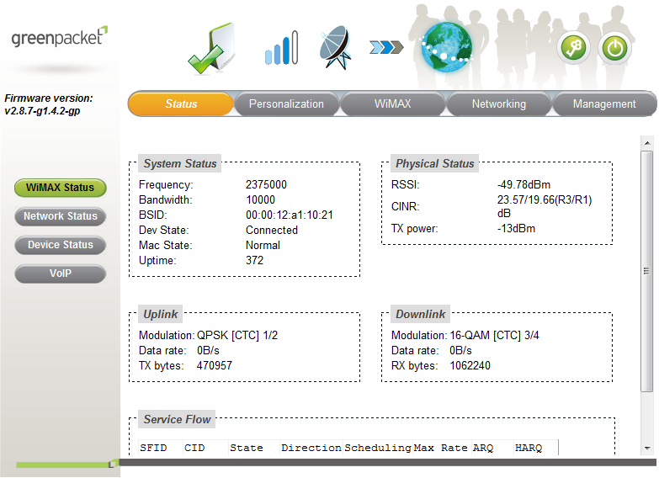
WiMAX Status

Click on “Status” on the top and “WiMAX Status” on the left, this tab gives you a summary of WiMAX status, such as the Frequency, BSID, RSSI, CINR and etc.

Network Status
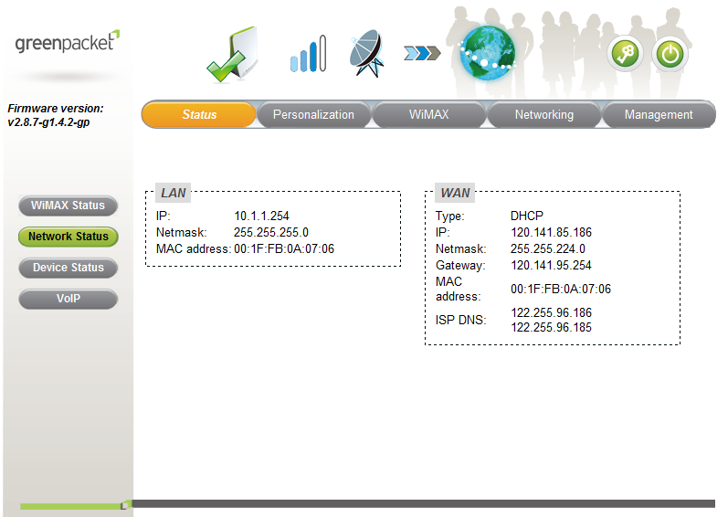
Network Status

Click on “Status” on the top and “Network Status” on the left, this tab gives you a summary of Network status, such as IP address, Gateway, Mac address and etc.

WiMAX Frequency Configuration

Scanner

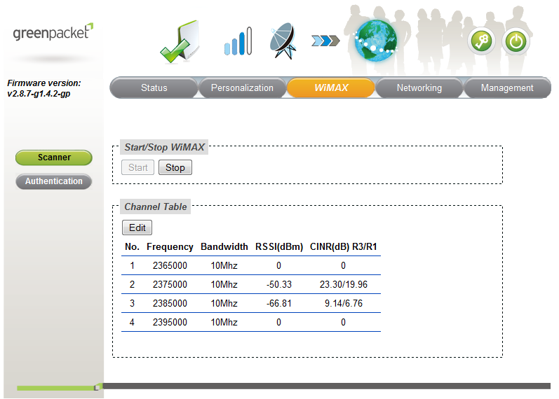
To Edit Frequency & Bandwidth
WiMAX Scanner

- Click on “WiMAX” on the top and “Scanner” on the left, you can start or stop the WiMAX connectivity.
- This Scanner tab, a list of BS which the CPE detected will be displayed in Channel Table.
- Press Edit button, can set insert and delete the Channel Frequency (KHz) and Bandwidth (MHz).

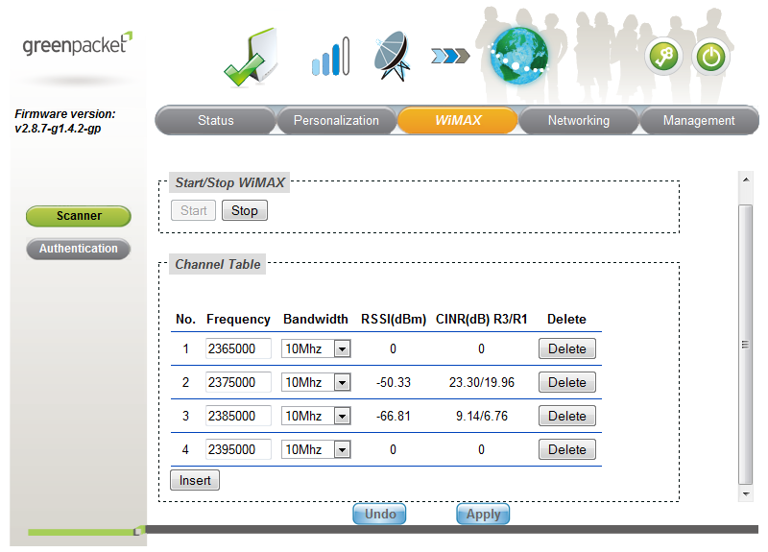
Insert and Delete Frequency

- Finally, click Apply button to save the configuration.

Note: set Frequency and Bandwidth is base on local WiMAX license.

WiMAX Authentication Configuration
WiMAX Authentication
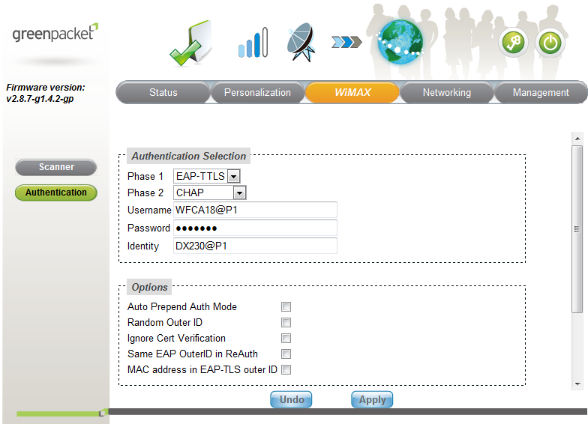

The following is the instruction of configuration:-

- This Authentication tab, configure the authentication settings for the WiMAX network.
- Choose the EAP type of Phase 1 and Phase 2 which your AAA is configured from EAP Method.
- Key in User Name and Password configured in AAA.
- Key in Identity ID
- Click Browse button at the CA Certificate and browse to the path where the CA Certificate is located.

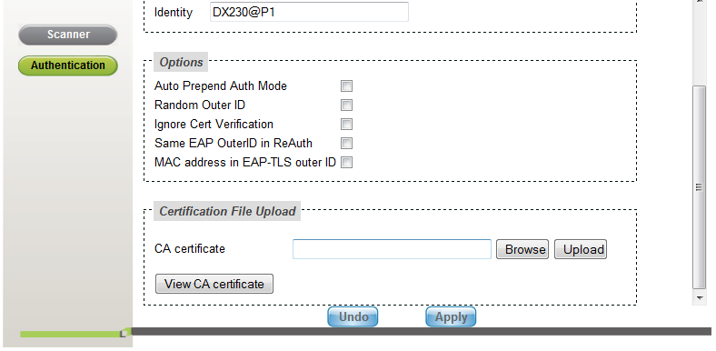

- Finally, click the Apply button to active the configured profile.

WIFI Configuration

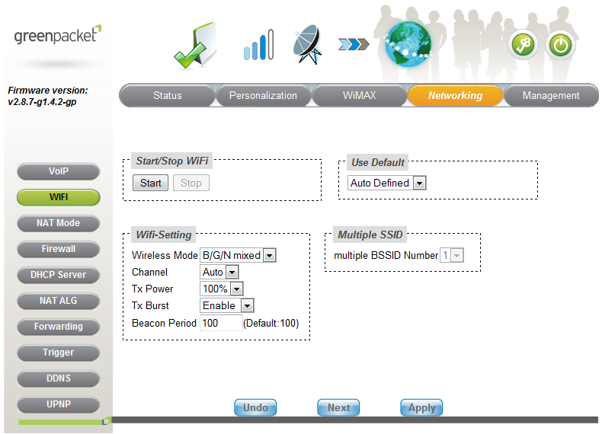
WIFI Network

The following is the instruction of configuration:-

- This WIFI tab, to configure the wireless settings for the end user network. End user can access the internet thru wireless connectivity.
- First, choose the wireless technologies mode as 802.11b/g/n mixed.
- Select Auto channel scanning.
- Make the transmit (Tx) power and burst is 100% and Enable.
- Click Next button to configure wireless network profile.

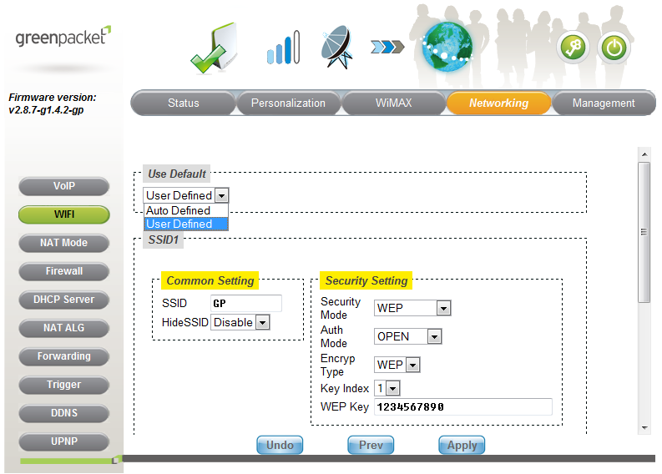

- Select User Defined as default.
- Create a wireless network name, known as SSID.
- Create wireless encryption (WEP) or (WiFi Protected Access (WPA), which help protect your wireless network.
- Finally, click Apply button save the wireless network configuration.

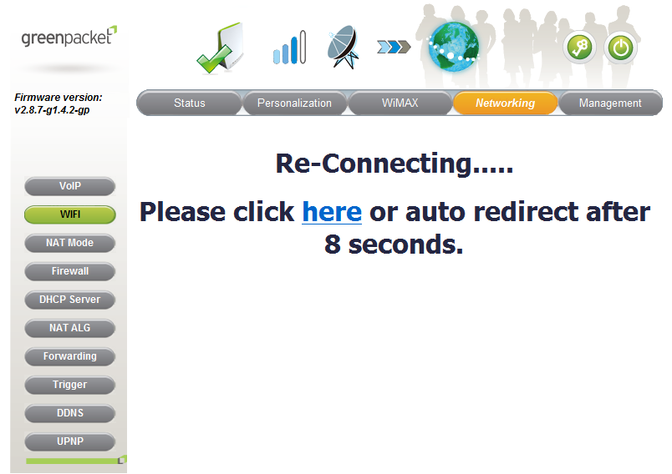

- System will auto re-connecting the setup after 10 seconds.

Firmware Upgrade

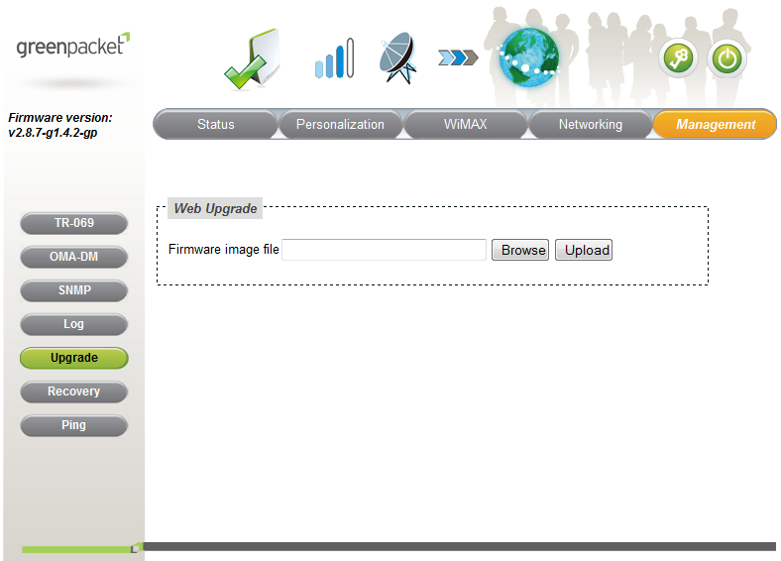
Management Upgrade

- This Upgrade tab, click browse button at the Firmware Image File and browse to the path where the Firmware is located.

Note: sample of file type: - xx_xx_ver x.x.x.x.tar.gz

Recovery

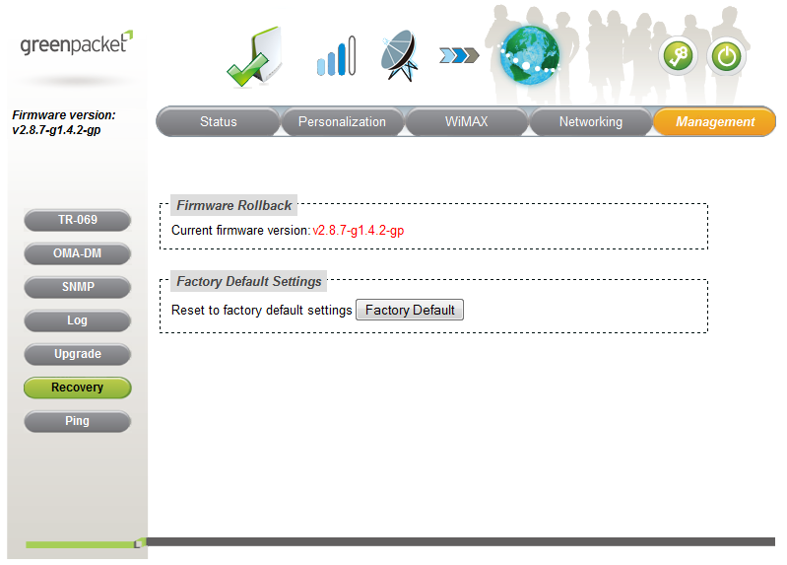
Management Recovery

- This Recovery tab is reset all the configuration and setting to factory default.

Logout and Reboot

Logout
Logout

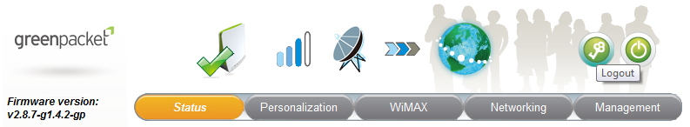

- This Logout tab is log off the user process at its end.

Reboot
Reboot

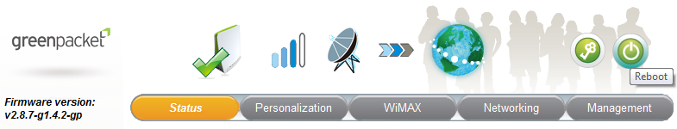

- Click Reboot button to restart CPE.
- System will reboot CPE and redirecting to login after 60 seconds.

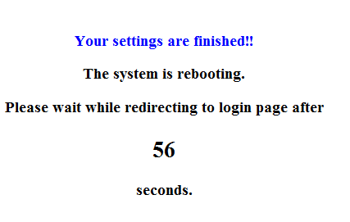

End Document

